MFE FORMWORK MR11 SYSTEM
System Architecture Document
Version 1.0
Prepared for
MFE Formwork
Prepared by
MyIntellX project team
Date
21 October 2026
Status
Draft for client review

Document control
Item | Detail
Document | System Architecture Document
System | MFE Formwork MR11 System, version 1.0
Document version | 1.0
Date | 21 October 2026
Status | Draft for client review
Based on | Repository izzatmyintellx05/MFE, branch main, commit 0cc8c36
Prepared for | MFE Formwork
Prepared by | MyIntellX project team
Intended readers | Client IT, future developers, auditors
Classification | Confidential, for client and vendor use only

Revision history
Version | Date | Description | Author
1.0 | 21 October 2026 | First issue for client review | MyIntellX project team

Contents
1. Introduction 4
2. Architecture overview 4
2.1 System context 5
2.2 Deployment 6
3. Technology stack 6
4. Components 7
4.1 Frontend pages and routes 8
5. How the main processes work 8
5.1 Uploading a workbook 8
5.2 Reading the MR11 10
5.3 Starting a new server instance 11
6. How the MR11 is put together 12
7. Data architecture 13
7.1 Tables the application uses 14
7.2 JSON structures 15
7.3 Tables that exist but are not written to 15
7.4 Two schema files 15
8. Security 16
9. Integrations 17
10. Key design decisions 17
11. Environments 18
Appendix A: Data dictionary 19
A.1 Enumerated types 19
A.2 Tables used by the application 19
A.3 Tables that version 1.0 does not write to 21
A.4 Differences in the Prisma migration layout 23
A.5 MR11 Master Schedule columns 24

1. Introduction
This document explains how the MFE Formwork MR11 System is put together: the parts it is made of, where they run, how data moves between them, and why it was designed this way. It is meant for the client's IT team, for developers who will look after the system, and for anyone reviewing it.
In short, the system is a single TypeScript code base. A React web app talks to an Express API running on Node.js, and Supabase PostgreSQL holds all lasting data. Each server instance keeps a working copy of the data in memory and refreshes it from the database, which is what allows the system to run as serverless functions on Vercel.
Appendix A lists every database table and column with its data type. The Data Models document goes into the structure of the data in more depth.

2. Architecture overview
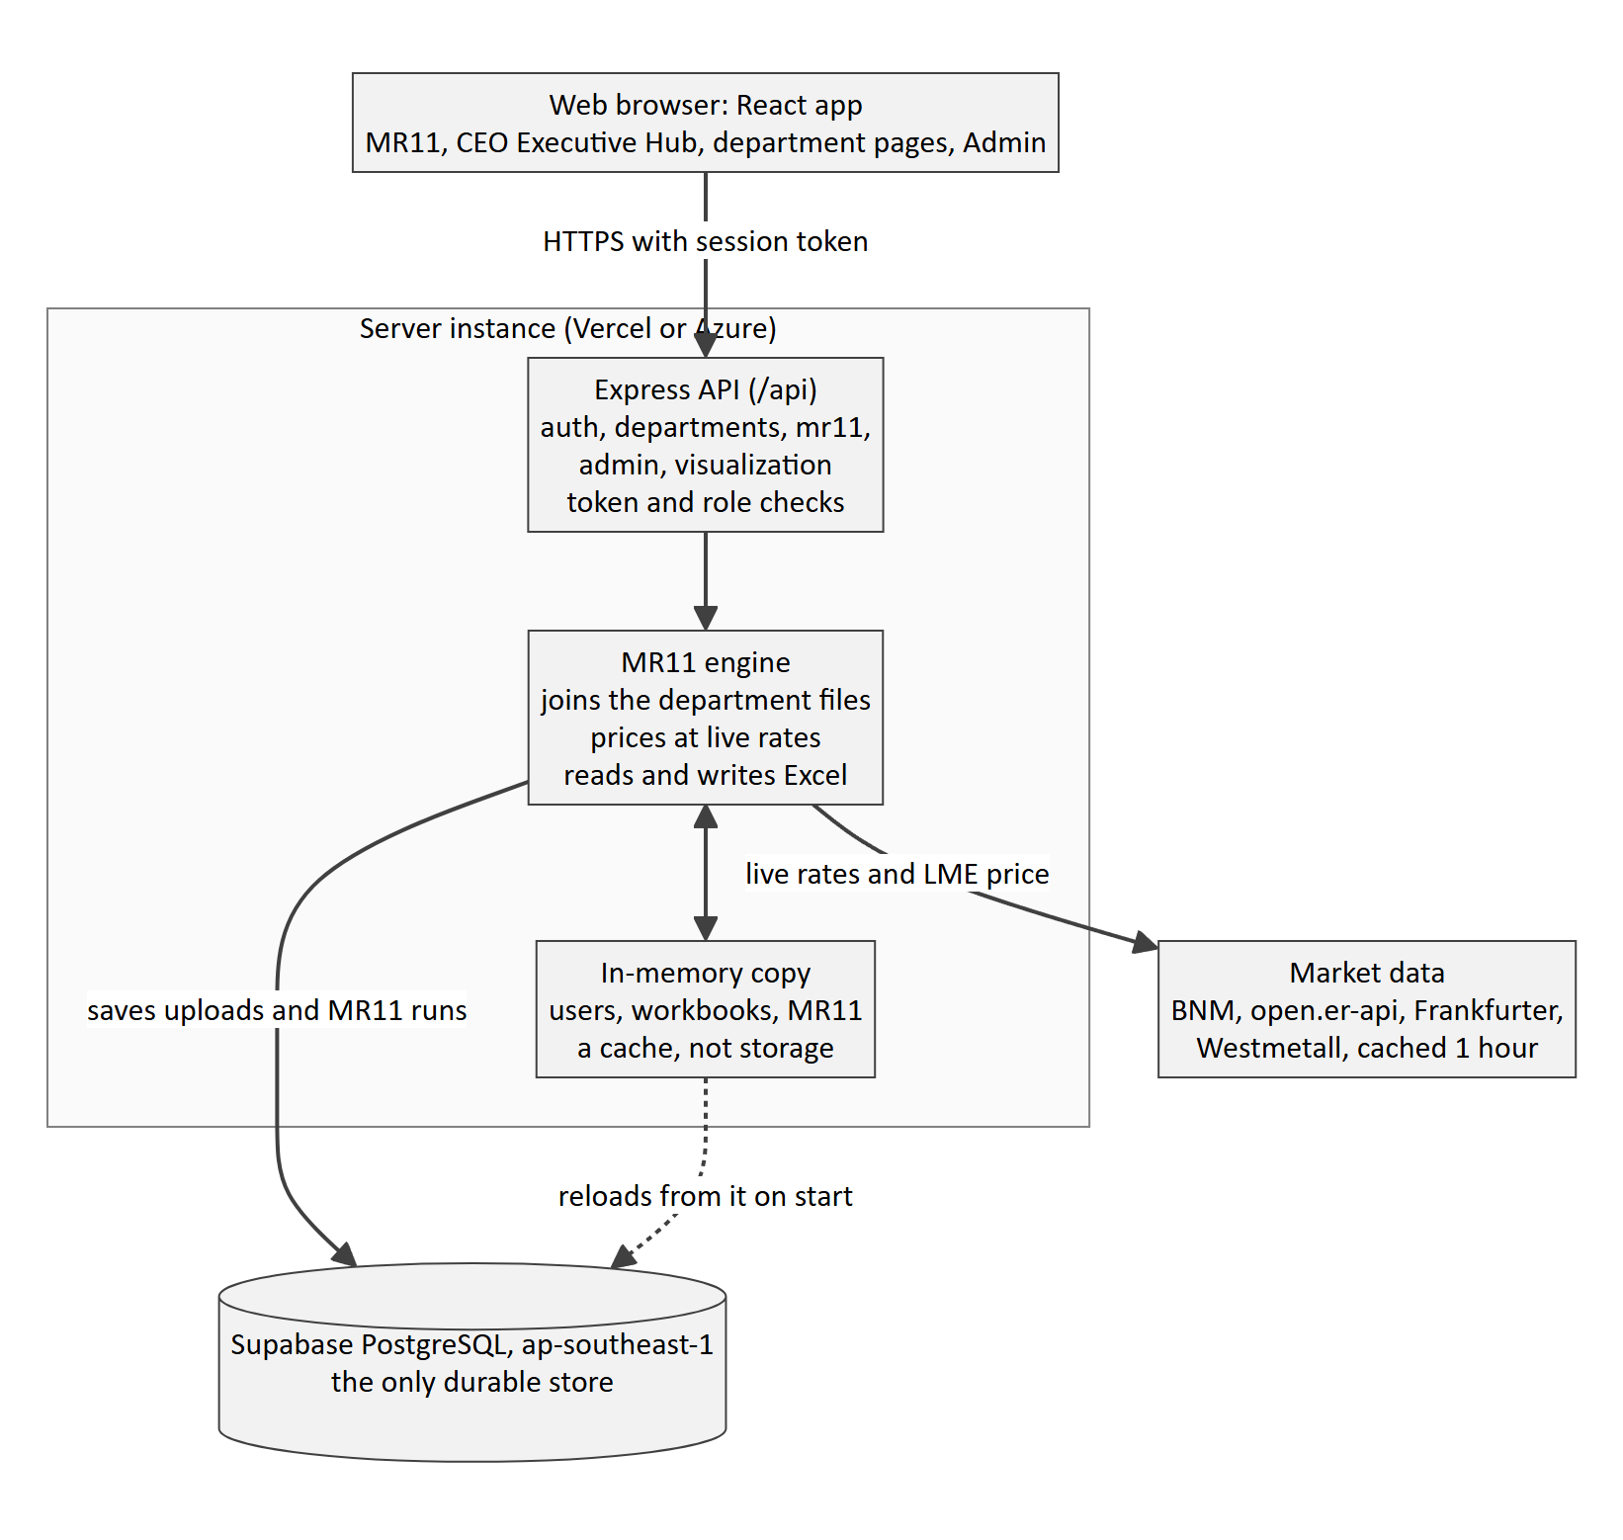
Figure 1: How the parts of the system fit together
Requests from the browser reach the API, which passes uploads and reads to the MR11 engine. The engine saves its results to Supabase, and every server instance reloads from Supabase before it serves requests.

2.1 System context
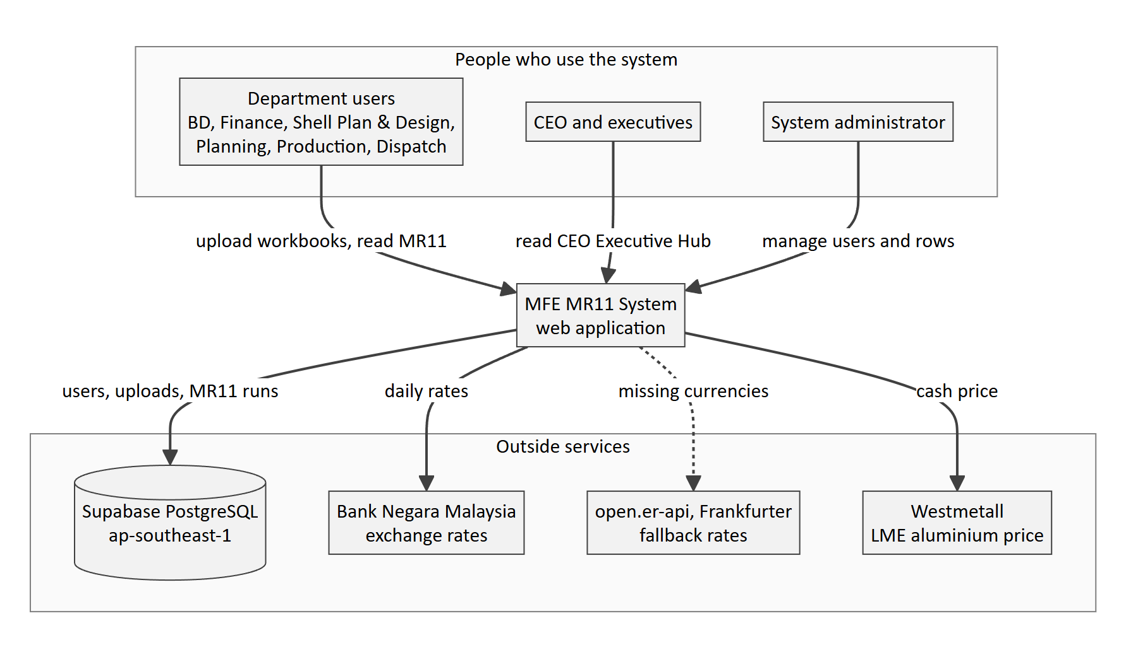
Figure 2: Who uses the system and which outside services it relies on
Three groups of people use the system, and it relies on four outside services. Only Supabase holds data. The market-data services are read-only and their answers are kept for an hour, so a short outage simply means users see the last known rate.

2.2 Deployment
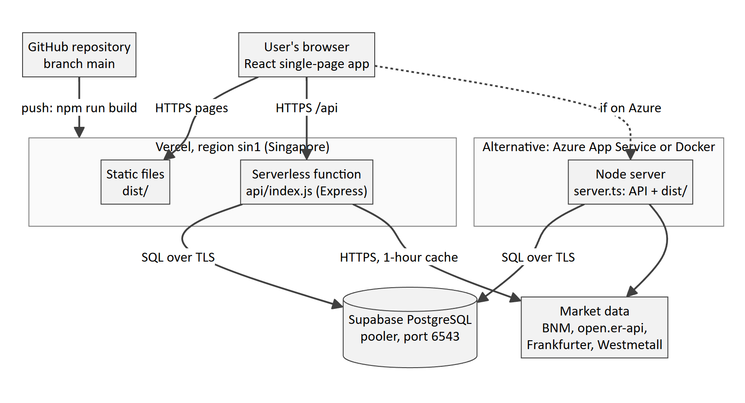
Figure 3: Deployment on Vercel (recommended) or Azure, both using the same Supabase database
On Vercel, the built pages in dist/ are served as static files and the whole Express app runs as one serverless function, api/index.js. On Azure or Docker, the same Express app runs as an ordinary Node server (server.ts) and serves the pages itself. Either way, the database is the same Supabase project.

3. Technology stack
Layer | Technology | Version (package.json) | What it is used for
Frontend | React and React Router | 19 and 7 | The single-page app and its page routing
Frontend | Zustand | 5 | Keeping track of who is signed in
Frontend | Tailwind CSS | 4 | Styling
Frontend | Chart.js with react-chartjs-2 | 4 and 5 | Charts on the CEO Executive Hub
Frontend | Axios | 1 | Calling the API with the session token
Build | Vite, esbuild and TypeScript | 8, 0.25 and 7 | Building the frontend and bundling the API for Vercel (api/index.js)
Backend | Node.js and Express | 22 and 4 | The HTTP API
Backend | Multer | 2 | Receiving uploads in memory, with nothing written to disk
Backend | ExcelJS | 4.4 | Reading workbooks with their formatting, and writing the MR11 export
Backend | jsonwebtoken and bcryptjs | 9 and 3 | Session tokens and password hashing
Data | node-postgres (pg) | 8 | Talking to Supabase PostgreSQL directly in SQL
Data | In-memory store (server/db/prisma.ts) | Not applicable | A working copy of the data on each server, with a Prisma-style interface; tsconfig.json points the @prisma/client import at it
Hosting | Vercel, region sin1 (Singapore) | Not applicable | The main hosting option, with Azure App Service and Docker as alternatives

4. Components
Component | Where it lives | What it does
Web app | src/ | The screens: sign-in, MR11, CEO Executive Hub, department pages, Planning, Production and Admin Permissions
API entry points | server.ts (local and Docker) and server/vercel.ts (Vercel) | Start Express and, in production, serve the built frontend
Express app | server/app.ts | Sets up CORS and request size limits, answers the health checks and connects the five API modules
Start-up loader | server/bootstrap.ts | Loads users, active workbooks and the latest MR11 from the database before the first request is answered
Auth module | server/modules/auth | Sign-in, the current user and password changes
Department module | server/modules/departments | Listing, viewing, uploading and downloading workbooks
MR11 module | server/modules/mr11 | The consolidation engine, pricing, the export, series and approval history, and row delete and restore
Admin module | server/modules/admin | Managing users and roles
Visualization module | server/modules/visualization | Summary figures for CEO and ADMIN users
Excel reader | server/utils/excel-normalizer.ts | Turns each sheet into cell data with values, fonts, fills and merges
Market data | server/utils/fx.ts and server/utils/lme.ts | Exchange rates and the LME aluminium price, each kept for one hour
Database access | server/db/supabase.ts | Reads from and writes to Supabase, and copes with both table layouts in the repository
Column map | server/config/mr11.config.ts | Says which department column feeds each MR11 column

4.1 Frontend pages and routes
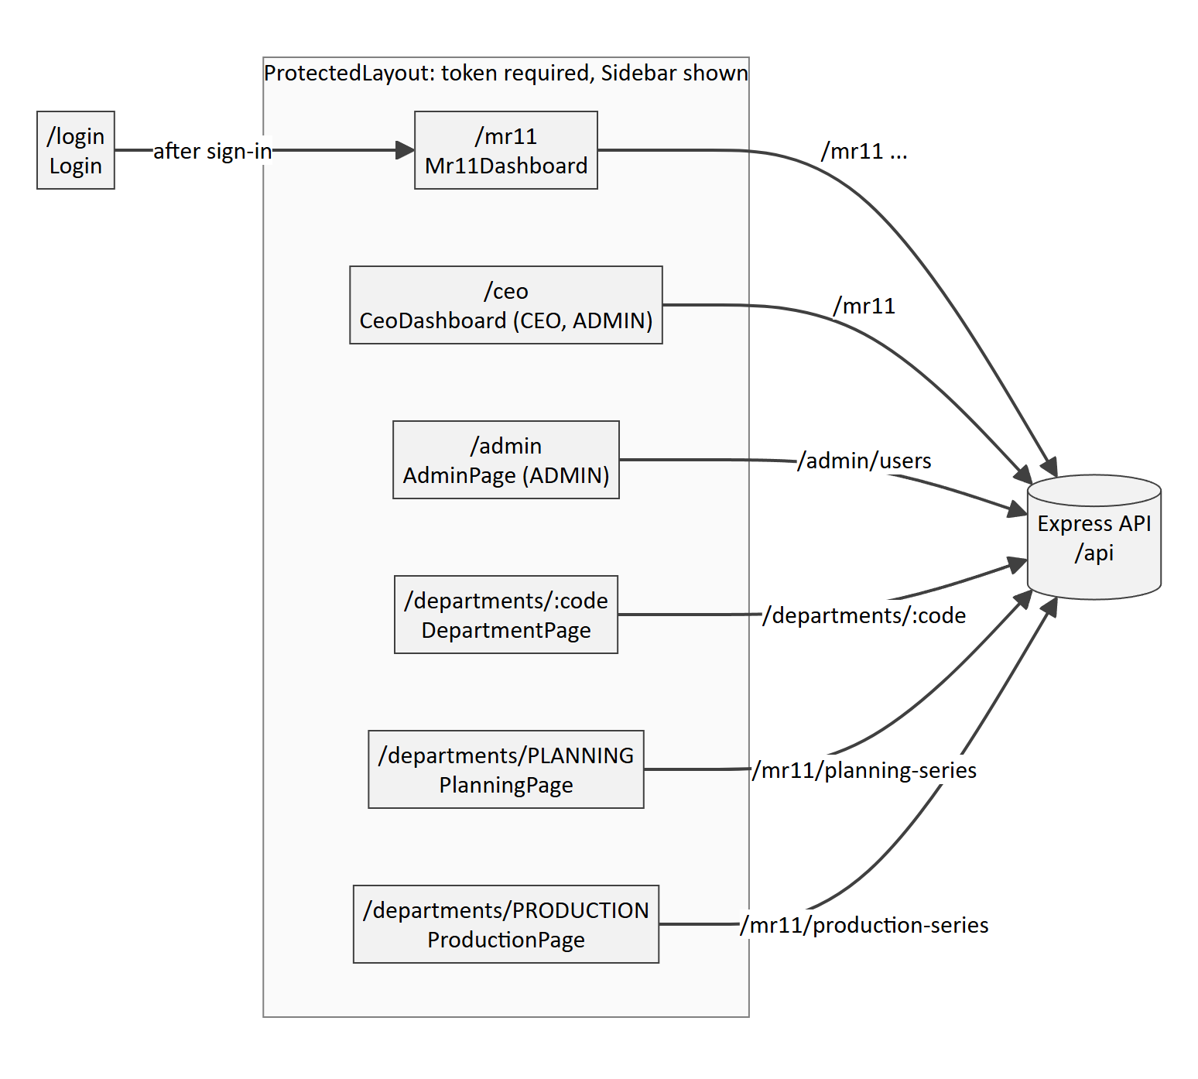
Figure 4: The frontend pages, who may open them, and the API each one calls
The routes are declared in src/App.tsx. ProtectedLayout sends anyone without a token to the sign-in page, and RequireAccess sends a signed-in user who lacks the right role back to the MR11. The server checks the same roles again on every API call, so hiding a page is a convenience rather than the real security boundary.

5. How the main processes work

5.1 Uploading a workbook
- A department user uploads an .xlsx file, which Multer holds in memory (up to 25 MB).
- The server checks that the user has that department's role, or ADMIN.
- ExcelJS reads every sheet into cell data, keeping values, font colours, fill colours and merged cells.
- For Dispatch, the file is stored as either the Local or the Overseas part, alongside the other part.
- The new version is saved to Supabase. It becomes the active version only once that save has succeeded.
- An UPLOAD_WORKBOOK entry is added to the audit log, which is kept in memory.
- The server reloads the other departments' latest versions from the database and runs the MR11 pipeline.
- The pipeline builds one row for each BD row, brings in the Finance, Shell Plan, Design, Planning, Production and Dispatch data, works out dates and monthly figures, and then sorts and merges the rows.
- The new MR11 run is saved to Supabase. If a newer upload arrived in the meantime, this older build is thrown away instead.
- Whenever someone opens the MR11, the prices are recalculated with today's exchange rates and LME price.
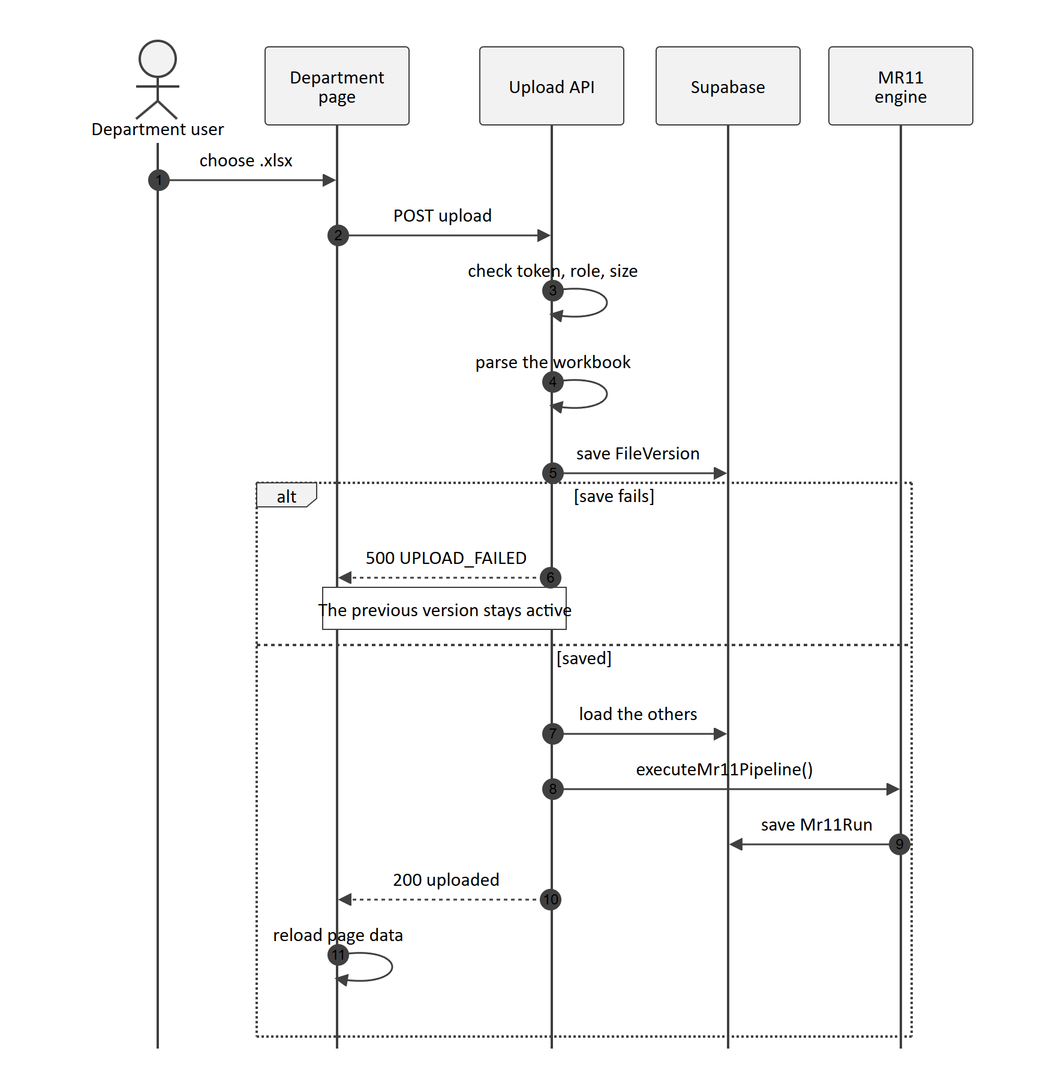
Figure 5: Uploading a workbook. The new version becomes active only after it is saved, and then the MR11 is rebuilt

5.2 Reading the MR11
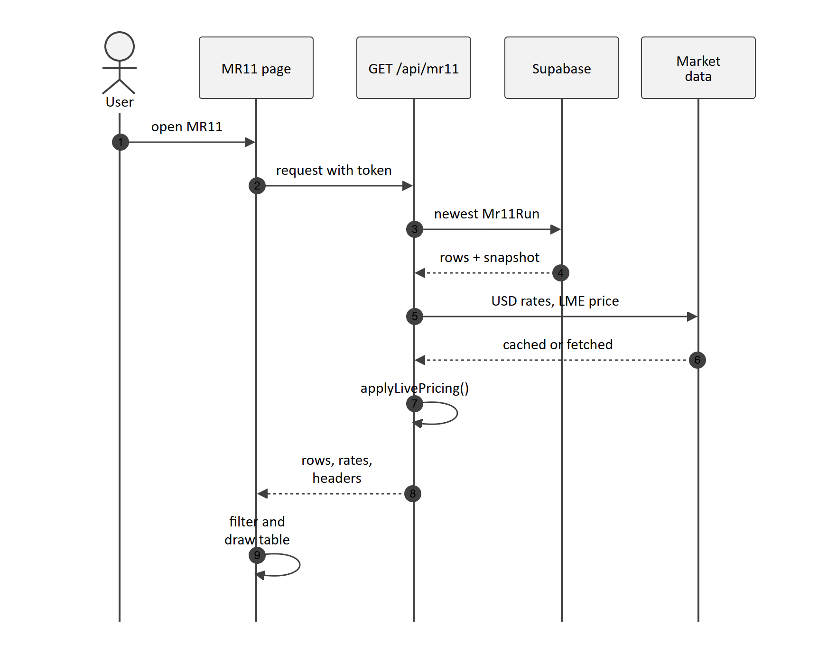
Figure 6: Reading the MR11. The newest run comes from Supabase and is priced with today's rates
Each stored MR11 row keeps the price inputs from its BD row in a field called _pricing. Every time the MR11 is read, Selling Price, LME Adjusted and Final Selling Price are worked out again from those inputs using the current rates, so prices follow the market every day without needing a rebuild.

5.3 Starting a new server instance
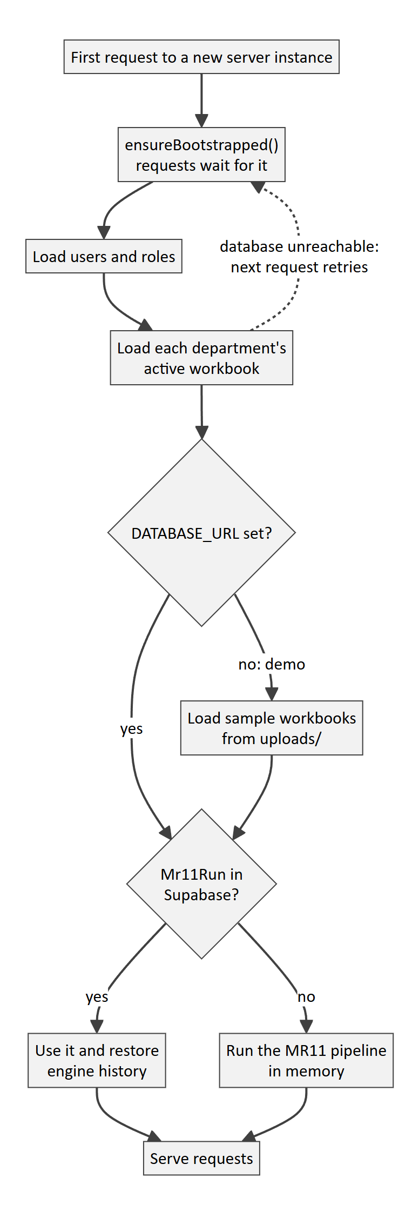
Figure 7: A new server instance loads everything from Supabase before it answers
A serverless platform starts and stops instances whenever it needs to. ensureBootstrapped() makes the first request wait until users, active workbooks and the latest MR11 have been loaded, so no instance ever answers from empty memory. If the database cannot be reached, the next request simply tries again.

6. How the MR11 is put together
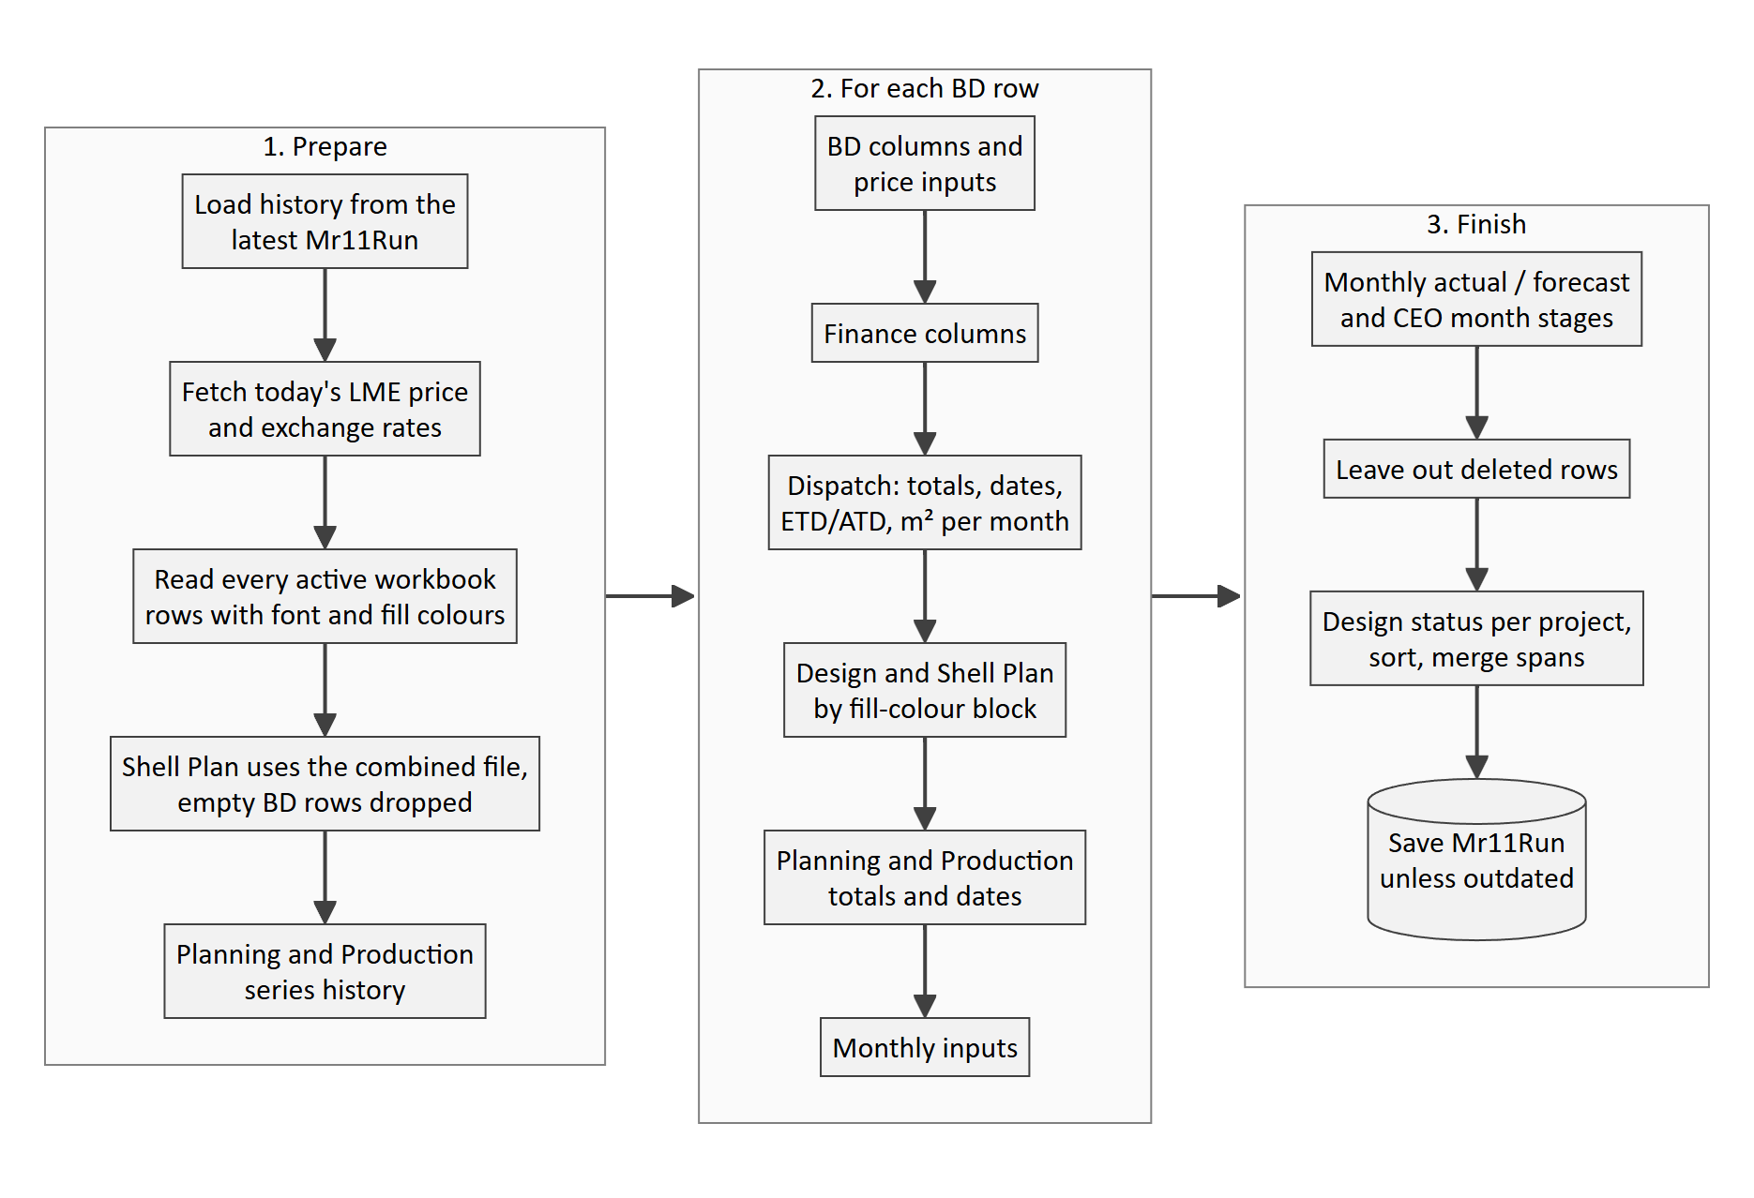
Figure 8: The MR11 pipeline (executeMr11Pipeline) in three stages
Stage | Rule
Master list | There is one MR11 row for each BD row that has a value in at least one cell
Matching projects | The short name is tried first, then the project number. A project number may carry the stream as its last digit, so 251242 means project 25124, stream 2
Matching colours | Rows match when their font and fill colours are within an RGB distance of 100 (SAME_COLOUR_DISTANCE). A row with no fill only matches another row with no fill
Finance | Same project and stream, then the closest colour, then the same product type
Shell Plan and Design | Matched by fill-colour block. Shell Plan takes its stream from the buildings listed in the Design file
Planning | Total Processed is the sum of Cumulative Processed (Project) for the row's blocks. Processed Date is the upload date on which that total last changed
Production | Total Produced is the sum of Cumulative Produced (Project). Produced Date is the latest daily column with output
Dispatch | Local or Overseas depends on which file lists the project, or failing that on the country (Peninsular Malaysia is Local)
Re-Design Only | BD rows in blue font stop at Planning, so Production and Dispatch show "-"
Monthly columns | Months that have ended show the m² dispatched, the current month shows what remains, and later months show BD's forecast
Sorting and merging | Rows are sorted by project, stream, unfilled before filled, fill colour and font colour. Rows of a stream with the same fill share merged Shell Plan and Design cells
Pricing | Selling Price combines the USD, MYR and other-currency prices. For Variable rows, LME Adjusted is the LME price minus the row's rate, divided by 1,000 and multiplied by 21.5

7. Data architecture
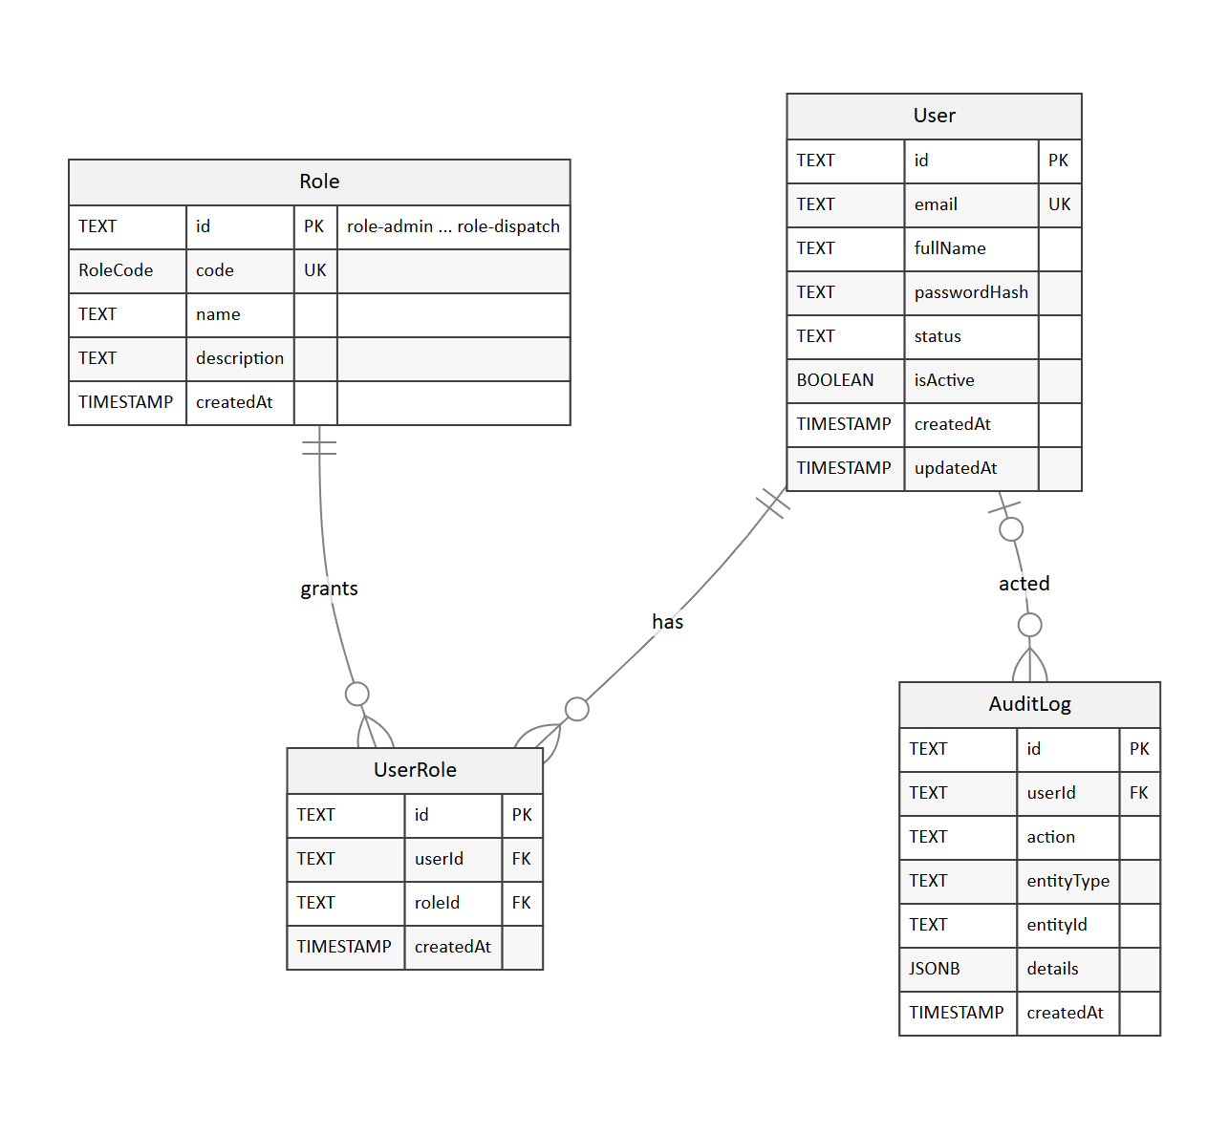
Figure 9: Accounts, roles and the audit log
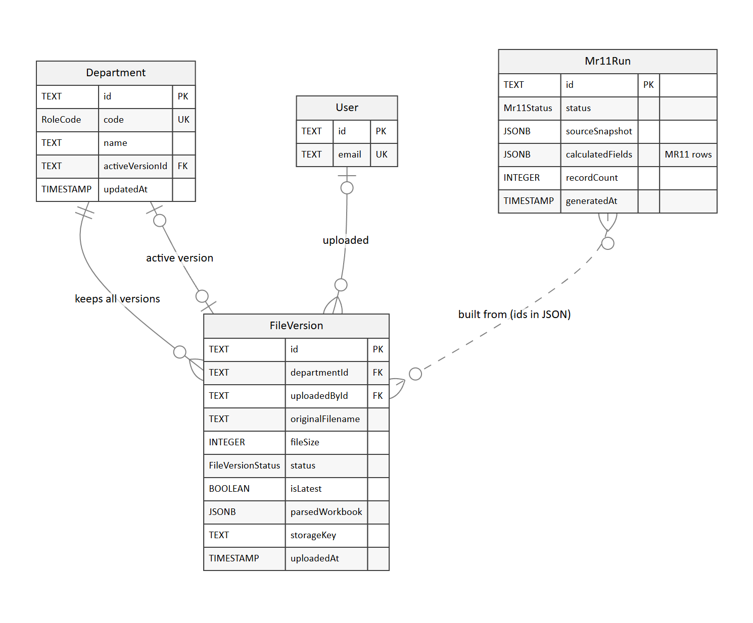
Figure 10: Departments, workbook versions and MR11 runs
Each department points to one active workbook version among all the versions it has kept, and each MR11 run records, inside its JSON snapshot, which workbook versions it was built from. Every column of every table is listed with its data type in Appendix A.

7.1 Tables the application uses
Table | Main columns | Notes
User | id, email (unique), fullName, passwordHash, status, isActive | The password hash is either pbkdf2$salt$hash (SHA-512) or, for accounts created in Admin Permissions, bcrypt
Role | id, code (unique), name | The ids must be role-admin, role-ceo, role-bd and so on up to role-dispatch
UserRole | userId and roleId, unique as a pair | Links users to roles, many to many
Department | id, code (unique), activeVersionId | Shell Plan & Design's combined workbook is kept under DESIGN
FileVersion | departmentId, originalFilename, storageKey, parsedWorkbook (JSONB), uploadedById, uploadedAt | One row for every upload, never deleted. For uploads made in the browser, storageKey is buffer://<name>
Mr11Run | status, sourceSnapshot (JSONB), records or calculatedFields (JSONB), recordCount, generatedAt | One row for every build; the newest one is shown

7.2 JSON structures
Structure | Where it is stored | What it holds
Workbook | FileVersion.parsedWorkbook | The sheets, with cell values, font and fill colours, merges and column widths. For Dispatch: { sheets, dispatchFiles: { LOCAL, OVERSEAS } }
MR11 row | Mr11Run.records | The 78 MR11 columns by name, plus internal fields such as _rowKey, _fontColor, _fillColor, _streamSpan, _designDateParts, _pricing, _dispatchedByMonth and _monthStages
Snapshot | Mr11Run.sourceSnapshot | The workbook version each department contributed, plus dispatchTracker, dispatchByMonth, localDispatchByMonth, productionByMonth, monthStageHistory, deletedRows, shellplanApprovalHistory and engineHistory

7.3 Tables that exist but are not written to
Table | What happens instead
AuditLog | The audit log is kept in server memory and is lost on restart
Mr11Config | Seeded with an empty column list and never changed
PlanningSeriesHistory, PlanningProjectQuantityTracker and ProductionSeriesHistory | This history is kept in memory and saved inside Mr11Run.sourceSnapshot.engineHistory

7.4 Two schema files
The repository describes the same tables in two slightly different layouts: supabase/schema.sql, which you run in the Supabase SQL editor and which we recommend, and prisma/migrations/0_init/migration.sql. The application only writes the columns a table actually has, so it works with either. Moving to a single layout would still be a good tidy-up.

8. Security
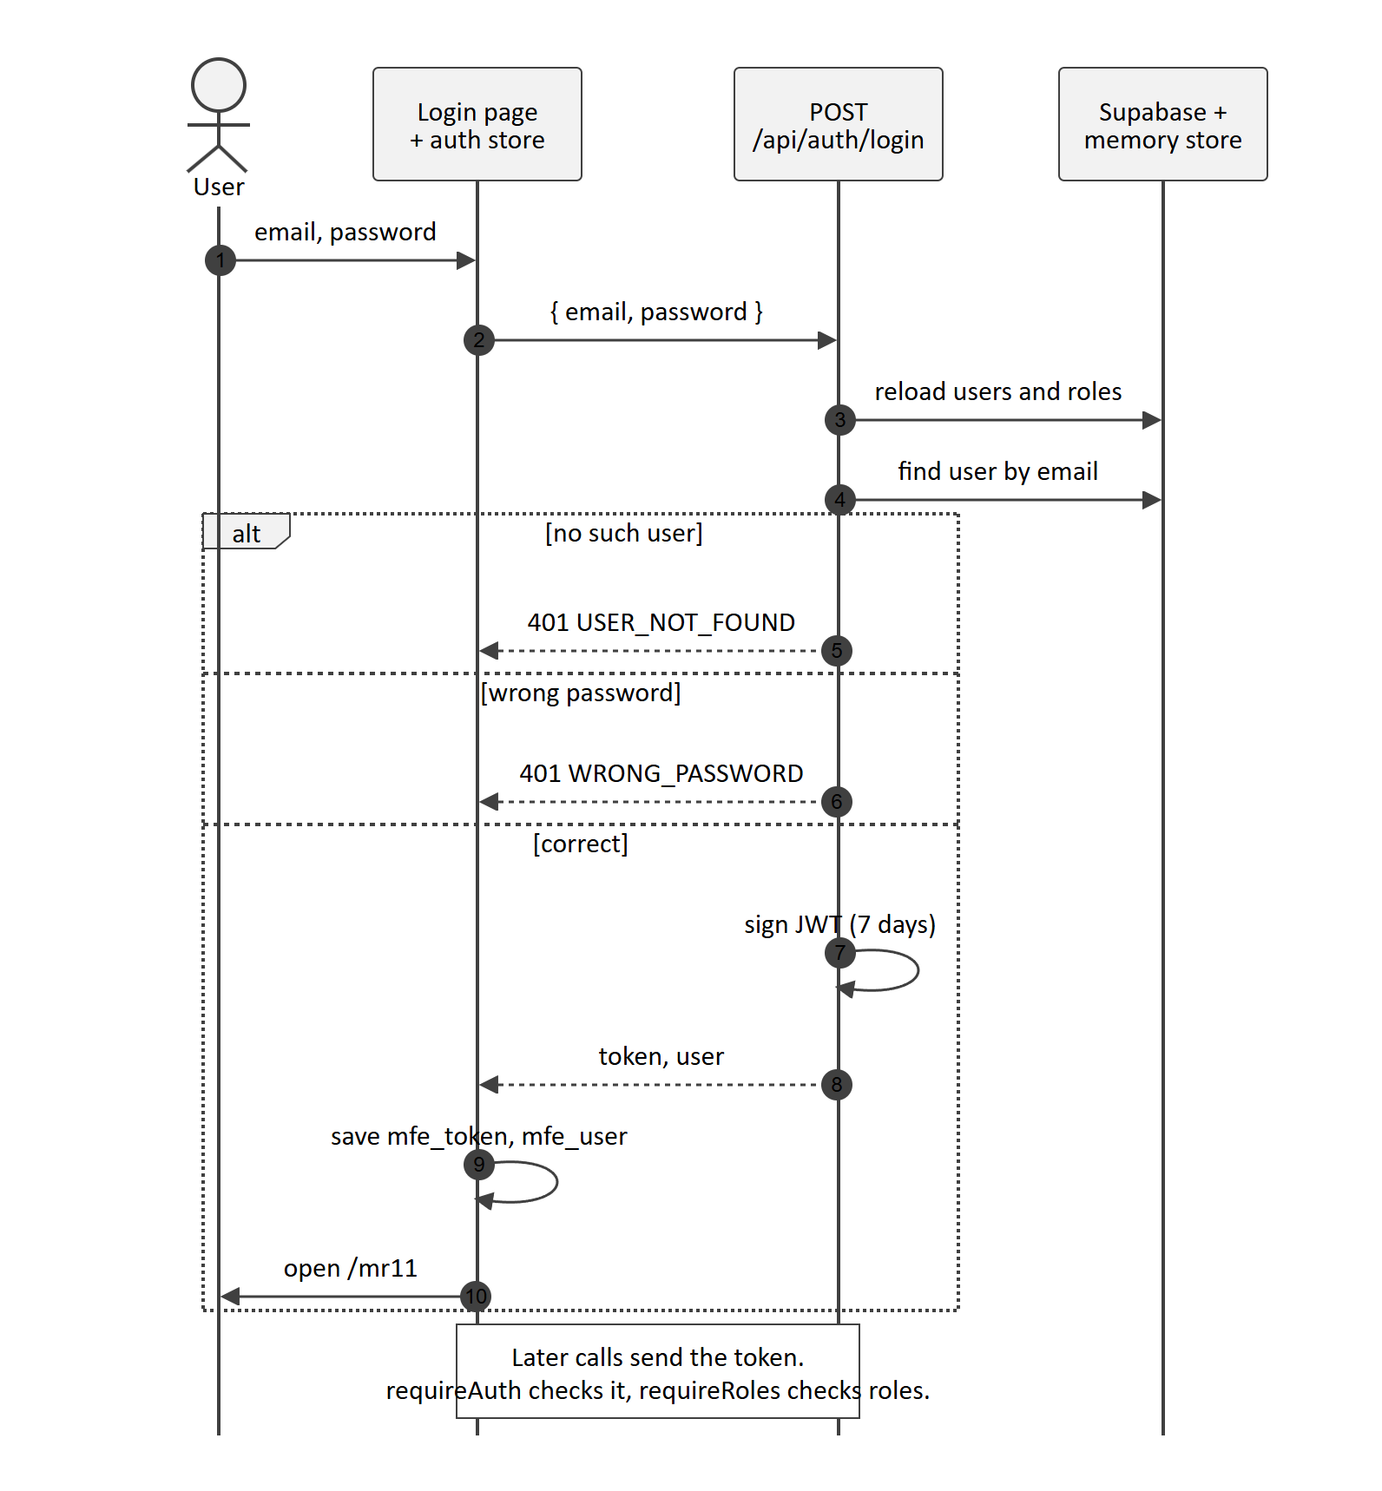
Figure 11: Signing in, and how later requests are checked
Concern | How it is handled
Authentication | Users sign in with an email address and password. The server issues a JWT (HS256), signed with JWT_SECRET, that is valid for 7 days
Session storage | The token and user details are kept in the browser's localStorage and sent with each request as Authorization: Bearer
Authorisation | Middleware on the server checks the roles in the token on every protected route, and ADMIN passes every check. The frontend hides pages using the same rules
Department isolation | A department's workbook can only be read or uploaded by that department (Shell Plan and Design together) or by ADMIN
Passwords | Hashed with PBKDF2-SHA512 (1,000 iterations) or bcrypt (cost 10)
Transport | HTTPS from Vercel or Azure, and TLS to Supabase. The database certificate is not verified (sslmode=no-verify)
Secrets | DATABASE_URL and JWT_SECRET are kept in the hosting platform's environment settings

The steps needed before go-live are listed in the security hardening checklist in the Operations and Support Guide.

9. Integrations
Service | What it provides | Endpoint | What happens if it fails
Bank Negara Malaysia open API | USD exchange rates (middle rate) | api.bnm.gov.my/public/exchange-rate | The system tries open.er-api.com, then Frankfurter (ECB), then the last rate it fetched, and finally USD_TO_MYR_RATE
Westmetall | LME aluminium cash and 3-month prices | The LME_Al_cash table on westmetall.com | The last price fetched is reused, and the card shows that it is not live
Supabase PostgreSQL | All lasting data | Transaction pooler, port 6543 | Reads are retried once, and failed saves are reported to the user

10. Key design decisions
Decision | Why | What it means
The database is the source of truth and memory is only a cache | Serverless instances can start and stop at any time | Every read or rebuild refreshes from Supabase first, and requests wait for the first load
Departments keep using Excel | No retraining is needed, and their colour conventions keep their meaning | Header names and colours have to stay consistent
Rows are matched by project, stream and nearest colour | Departments use slightly different shades for the same block | Colours within a distance of 100 are treated as the same
Prices are calculated when the MR11 is read | LME prices and exchange rates change every day | The MR11 always shows today's prices, while stored runs keep the inputs
The engine's history is kept inside each MR11 run | Series, approval history, monthly dispatch figures and deleted rows must survive restarts | A single JSON snapshot carries all of this history forward
Writes adapt to the columns a table has | The repository has two table layouts | Either layout works, though moving to one is recommended

11. Environments
Environment | Hosting | Database
Local demonstration | npm run dev | None; everything is in memory, using the sample workbooks
Local development | npm run dev | Local PostgreSQL on port 5433
Staging (recommended for UAT) | A Vercel preview deployment | A separate Supabase project
Production | Vercel sin1 or Azure App Service | Supabase ap-southeast-1

Appendix A: Data dictionary
This appendix lists every database table, and the columns of the MR11 Master Schedule, with their data types. The database types are the PostgreSQL types created by supabase/schema.sql, the install script we recommend. Section A.4 lists the places where the Prisma migration layout is different.

A.1 Enumerated types
Type | Allowed values | Used in
RoleCode | ADMIN, CEO, BD, FINANCE, SHELLPLAN, DESIGN, PLANNING, PRODUCTION, DISPATCH | Role.code and Department.code
Mr11Status | EMPTY, PARTIAL, READY, FAILED | Mr11Run.status
FileVersionStatus | UPLOADING, PROCESSING, READY, FAILED | FileVersion.status

A.2 Tables used by the application
User: the people who can sign in.
Column | Data type | Null | Default | Key and notes
id | TEXT | No | None | Primary key; a UUID, or a fixed seed id such as user-admin-1
email | TEXT | No | None | Unique (User_email_key); stored in lower case
fullName | TEXT | No | None | The name shown on screen
passwordHash | TEXT | No | None | A pbkdf2$salt$hash value or a bcrypt hash
status | TEXT | No | 'ACTIVE' | Account status
isActive | BOOLEAN | No | true
createdAt | TIMESTAMP(3) | No | CURRENT_TIMESTAMP
updatedAt | TIMESTAMP(3) | No | CURRENT_TIMESTAMP

Role: the nine roles, which are seeded with fixed ids.
Column | Data type | Null | Default | Key and notes
id | TEXT | No | None | Primary key; role-admin, role-ceo, role-bd and so on up to role-dispatch
code | RoleCode | No | None | Unique (Role_code_key)
name | TEXT | No | None
description | TEXT | Yes | None
createdAt | TIMESTAMP(3) | No | CURRENT_TIMESTAMP

UserRole: links users to roles.
Column | Data type | Null | Default | Key and notes
id | TEXT | No | None | Primary key
userId | TEXT | No | None | Refers to User.id; unique together with roleId
roleId | TEXT | No | None | Refers to Role.id
createdAt | TIMESTAMP(3) | No | CURRENT_TIMESTAMP

Department: the seven departments and their active workbook.
Column | Data type | Null | Default | Key and notes
id | TEXT | No | None | Primary key; dept-bd, dept-finance and so on
code | RoleCode | No | None | Unique (Department_code_key)
name | TEXT | No | None
description | TEXT | Yes | None
activeVersionId | TEXT | Yes | None | The FileVersion.id of the workbook in use
createdAt | TIMESTAMP(3) | No | CURRENT_TIMESTAMP
updatedAt | TIMESTAMP(3) | No | CURRENT_TIMESTAMP

FileVersion: every workbook that has been uploaded.
Column | Data type | Null | Default | Key and notes
id | TEXT | No | None | Primary key; a UUID
departmentId | TEXT | No | None | Refers to Department.id
uploadedById | TEXT | No | None | Refers to the User.id of the uploader
originalFilename | TEXT | No | None | For Dispatch, in the form "Local: ... / Overseas: ..."
storagePath | TEXT | No | None | The same value as storageKey
fileSize | INTEGER | No | None | In bytes
status | FileVersionStatus | No | 'PROCESSING' | The application saves READY
isLatest | BOOLEAN | No | true | Set to false on the department's older versions
sheetMetadata | JSONB | Yes | None | Not used
rawDataJson | JSONB | Yes | None | A copy of parsedWorkbook
errorMessage | TEXT | Yes | None | Not used
uploadedAt | TIMESTAMP(3) | No | CURRENT_TIMESTAMP
storageKey | TEXT | Yes | None | buffer://<file name> for uploads made in the browser
mimeType | TEXT | Yes | None
parsedWorkbook | JSONB | Yes | None | The workbook as cell data with its formatting
processedAt | TIMESTAMP(3) | Yes | None
createdAt | TIMESTAMP(3) | No | CURRENT_TIMESTAMP

Mr11Run: every build of the MR11; the newest one is the one shown.
Column | Data type | Null | Default | Key and notes
id | TEXT | No | None | Primary key
generatedAt | TIMESTAMP(3) | No | CURRENT_TIMESTAMP | Used to find the latest run
generatedById | TEXT | Yes | None | Not used
status | Mr11Status | No | 'EMPTY' | The application saves READY
sourceSnapshot | JSONB | Yes | None | The workbook versions used, plus the history carried forward
calculatedFields | JSONB | Yes | None | The MR11 rows (see A.5)
summaryMetrics | JSONB | Yes | None | Not used
recordCount | INTEGER | No | 0 | The number of MR11 rows

A.3 Tables that version 1.0 does not write to
Mr11Config
Column | Data type | Null | Default | Key and notes
id | TEXT | No | None | Primary key; a single row called 'singleton'
visibleColumns | TEXT[] | Yes | None | Seeded empty
updatedAt | TIMESTAMP(3) | No | CURRENT_TIMESTAMP
updatedById | TEXT | Yes | None

AuditLog (kept in server memory instead)
Column | Data type | Null | Default | Key and notes
id | TEXT | No | None | Primary key
userId | TEXT | No | None | Refers to User.id
action | TEXT | No | None | For example UPLOAD_WORKBOOK
entityType | TEXT | No | None | For example DEPARTMENT
entityId | TEXT | Yes | None
details | JSONB | Yes | None
createdAt | TIMESTAMP(3) | No | CURRENT_TIMESTAMP

PlanningSeriesHistory (kept inside Mr11Run.sourceSnapshot instead)
Column | Data type | Null | Default | Key and notes
id | TEXT | No | None | Primary key
projectNo | TEXT | No | None | Unique together with stream, fontColor and seriesNumber
projectShortname | TEXT | Yes | None
stream | TEXT | Yes | None
fontColor | TEXT | Yes | None | A hex colour such as #000000
seriesNumber | INTEGER | No | None
totalProcessed | DOUBLE PRECISION | Yes | None | In m²
detectedAt | TIMESTAMP(3) | No | CURRENT_TIMESTAMP
updatedAt | TIMESTAMP(3) | No | CURRENT_TIMESTAMP
sourceFileVersionId | TEXT | Yes | None

PlanningProjectQuantityTracker (kept inside Mr11Run.sourceSnapshot instead)
Column | Data type | Null | Default | Key and notes
id | TEXT | No | None | Primary key
projectNo | TEXT | No | None | Unique together with stream and fontColor
projectShortname | TEXT | Yes | None
stream | TEXT | Yes | None
fontColor | TEXT | Yes | None
totalTargetQuantity | DOUBLE PRECISION | No | None | In m²
totalProcessed | DOUBLE PRECISION | No | 0 | In m²
balanceQuantity | DOUBLE PRECISION | No | 0 | In m²
sourceFileVersionId | TEXT | Yes | None
createdAt | TIMESTAMP(3) | No | CURRENT_TIMESTAMP
updatedAt | TIMESTAMP(3) | No | CURRENT_TIMESTAMP

ProductionSeriesHistory (kept inside Mr11Run.sourceSnapshot instead)
Column | Data type | Null | Default | Key and notes
id | TEXT | No | None | Primary key
projectShortname | TEXT | No | None | Unique together with stream, fontColor and seriesNumber
stream | TEXT | Yes | None
fontColor | TEXT | Yes | None
seriesNumber | INTEGER | No | None
totalFabricated | DOUBLE PRECISION | Yes | None | In m²
detectedAt | TIMESTAMP(3) | No | CURRENT_TIMESTAMP
updatedAt | TIMESTAMP(3) | No | CURRENT_TIMESTAMP
sourceFileVersionId | TEXT | Yes | None

A.4 Differences in the Prisma migration layout
prisma/migrations/0_init/migration.sql creates the same tables with the differences below. The application works with either layout.
Table | How the Prisma layout differs
All tables | updatedAt has no default. Foreign keys are declared: UserRole to User and to Role (deleted together); FileVersion to Department (deleted together); FileVersion.uploadedById and AuditLog.userId to User (set to null when the user is deleted); Department.activeVersionId to FileVersion (set to null)
Department | activeVersionId must also be unique
FileVersion | There are no storagePath, isLatest, sheetMetadata, rawDataJson or errorMessage columns, and there is an extra checksumSha256 TEXT column. storageKey is NOT NULL, fileSize and uploadedById may be null, and status defaults to 'READY'
Mr11Run | The rows are in records (JSONB, NOT NULL) instead of calculatedFields, sourceSnapshot is NOT NULL, and there are no generatedById or summaryMetrics columns
Mr11Config | visibleColumns is JSONB and NOT NULL, id defaults to 'singleton', and there is no updatedById column
AuditLog | details is called metadata, and userId may be null
PlanningSeriesHistory | Adds projectName TEXT, totalQuantity DOUBLE PRECISION and closingDate TEXT. stream and fontColor are NOT NULL (fontColor defaults to '#000000'), totalProcessed is NOT NULL with a default of 0, and there is no sourceFileVersionId
PlanningProjectQuantityTracker | Has projectName TEXT, lastQuantity DOUBLE PRECISION (NOT NULL, default 0) and lastChangedDate TEXT (NOT NULL) instead of the three quantity columns. stream and fontColor are NOT NULL
ProductionSeriesHistory | Adds projectNo TEXT and projectName TEXT, uses totalProduced DOUBLE PRECISION (NOT NULL, default 0) instead of totalFabricated, and makes stream and fontColor NOT NULL

A.5 MR11 Master Schedule columns
Each MR11 row is stored as a JSON object inside Mr11Run. Text values are JSON strings, numbers are JSON numbers, and dates are text in the form YYYY-MM-DD. These are the 78 columns, in the order they appear on screen.
# | Column | Data type | Source | Notes
1 | Customer & Project Name | Text | BD
2 | Project No | Text | BD | The 5-digit project number
3 | Short Name | Text | BD | The main key used for matching
4 | Stream | Text | BD | 1, 2, 3 and so on; it may come from the project number
5 | Building Name | Text | BD
6 | Countries | Text | BD | Decides between Local and Overseas dispatch
7 | Location | Text | BD | The city or site
8 | PIC | Text | BD | The person in charge
9 | Status | Text | BD
10 | Products type | Text | BD
11 | Formwork type | Text | BD
12 | Remarks | Text | BD
13 | PO | Text | BD
14 | PO date | Date | BD
15 | NCA | Text | BD
16 | NCA date | Date | BD
17 | Original NCA Qty | Number | BD
18 | NCA Remarks | Text | BD | BD's second Remarks column
19 | Payment terms - Percentage | Number | BD | A percentage
20 | Payment terms - Amount | Number | BD | USD, 2 decimal places
21 | Payment terms - Type | Text | BD
22 | Payment terms - Balance Percentage | Number | BD | A percentage
23 | Payment terms - Amount 2 | Number | BD | USD, 2 decimal places
24 | Payment terms - Type 2 | Text | BD
25 | Payment terms - Balance Percentage 2 | Number | BD | A percentage
26 | Payment terms - Amount 3 | Number | BD | USD, 2 decimal places
27 | Payment terms - Type 3 | Text | BD
28 | Selling Price (USD) | Number | BD, then calculated | USD, MYR and any other currency, at today's rates
29 | LME | Text | BD | Fixed, Freeze or Variable
30 | LME Rate (USD) | Number | BD | USD per tonne, 3 decimal places
31 | Incoterms | Text | BD
32 | Props, WPB, Waler, Acc (USD) | Number | BD | USD
33 | Aluminium Weight Adjusted (USD) | Number | BD | USD
34 | LME Adjusted (USD) | Number, or the text "Check" | Calculated | 3 decimal places; "Check" for Freeze rows
35 | Freight Adjusted (USD) | Number | BD | USD
36 | Final Selling Price (USD) | Number | Calculated | 3 decimal places
37 | Advance Received / Payment Status | Text | Finance
38 | Actual Received | Number | Finance
39 | Payment Date | Date | Finance
40 | Shell Plan Status - Pending Consultant Drawings | Text | Shell Plan | In Progress, Pending Drawings, Reapprove or Approved
41 | Shell Plan Approved Date | Date | Shell Plan
42 | Formwork Design Status | Text | Design | Fully Complete, Partially Complete, Ongoing or To Start
43 | Actual Formwork Order Completion Date | Text (one or more dates) | Design | A single date, or one date per level, such as "Typical: 2026-11-04"
44 | Total Quantity Ordered m2 | Number | Design | m²
45 | Total Processed | Number | Planning | m²; the sum of Cumulative Processed (Project)
46 | Processed Date | Date | Calculated | The upload date of the last change
47 | Total Produced | Number, or "-" | Production | m²; "-" for Re-Design Only rows
48 | Produced Date | Date, or "-" | Production | The latest daily column with output
49 | Total Dispatch | Number, or "-" | Dispatch | m²; the sum of Cumulative Dispatched (Project)
50 | Dispatch Date | Date, or "-" | Dispatch
51 | Formwork Quantity Sailed (m2) | Number, or "-" | Dispatch | m²
52 | ETD/ATD | Text over several lines | Dispatch | Lines starting "ETD:", "ATD:" or "Delivered:", with dates and m²
53 to 64 | Jan-26 to Dec-26 | Number | BD and Dispatch | m² for each month: actual for months that have ended, forecast after that
65 | Total 2026 m2 | Number | Calculated | The sum of the 2026 months
66 to 77 | Jan-27 to Dec-27 | Number | BD and Dispatch | m² for each month
78 | Total 2027 m2 | Number | Calculated | The sum of the 2027 months

Each row also carries internal fields, whose names start with an underscore, that are not shown on screen: _rowKey (text), _fontColor and _fillColor (hex text), _streamSpan (a number), _designDateParts (a list of level, date and completed flag), _pricing (the BD price inputs), _dispatchedByMonth (m² for each month) and _monthStages (figures for the CEO pipeline).

